**Weekly challenge 4**

A data analyst is working with a spreadsheet from a furniture company.

The analyst inputs a function to find the number of product prices that are less than $150.00. Which formula will return that result?

=SUMIF(G2:G30, “<150”)

=COUNTIF(G2:G30, “>=150”)

**=COUNTIF(G2:G30, “<150”)**

=SUMIF(G2:G30, “>150”)

**Correct**

The COUNTIF formula =COUNTIF(G2:G30, “<150”) will allow the analyst to count all product price values in Column G that are less than $150.

### 2.You are working in a spreadsheet and use the SUMIF function in the formula below as part of your analysis.

=SUMIF(A1:A25, ”<10”, C1:C25)

Which part of this formula is the criteria or condition?

**”<10”**

C1:C25

A1:A25

=SUMIF

**Correct**

The criteria or condition for this SUMIF formula is “<10”. This means that if any values in the range A1 through A25 are less than 10, their corresponding values in the range C1 through C25 will be added together.

### 3.The following is a formula with the SUMPRODUCT function:

=SUMPRODUCT(A2:A10,B2:B10).

It will add the values from the first range (A2:A10) to the values from the second range (B2:B10). Then, the sums will be multiplied.

True

**False**

**Correct**

The formula will multiply the first range of values (A2:A10) by the second range of values (B2:B10). Then, the products will be added together.

### 4.You create a pivot table in a spreadsheet containing movie data. To use the template for this spreadsheet,

If you want to figure out how much box office revenue each genre earned, which function in the Values menu would you use to summarize the data?

AVERAGE

PRODUCT

**SUM**

COUNTA

**Correct**

You would use the SUM function to figure out how much box office revenue each genre earned. In the pivot table, the SUM function would add the total revenue separately for each genre.

### 5.A data analyst uses the following SQL query to perform basic calculations on their data. Which types of operators is the analyst using in this SQL query? Select all that apply.

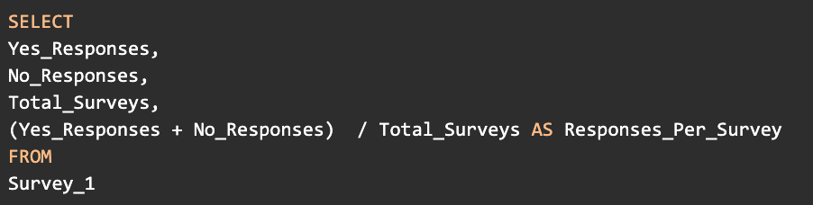SELECT Yes_Responses, No_Responses, Total_Surveys, (Yes_Responses + No_Responses) / Total_Surveys AS Responses_Per_Survey FROM Survey_1

**Addition**

**.Division**

Multiplication

Subtraction

### 6.You are working with a database table that contains data about music. The table includes columns for track_id, track_name, composer, and album_id. You are only interested in data about the classical musician Johann Sebastian Bach. You want to create new album IDs. You decide to multiply the current album IDs by 10 to create new album IDs, and use the AS command to store them in a new column called new_album_id.

Add a statement to your SQL query that calculates a new album Id for each track and stores it in a new column as new_album_id.

NOTE: The three dots (...) indicate where to add the statement.

SELECT

track_id,

track_name,

composer,

album_id,

. . .

FROM

track

WHERE

composer = "Johann Sebastian Bach"

RunReset

What is the new album ID for the track with Id number 3490?

3000

**3350**

2970

2760

**Correct**

You add the statement **album_id * 10 AS new_album_id** to calculate a new album ID for each track and store it in a new column as new_album_id. The complete query is **SELECT track_id, track_name, composer, album_id, album_id * 10 AS new_album_id FROM track WHERE composer = “Johann Sebastian Bach”**. The AS command gives a temporary name to the new column.

The new Album Id for the track with Id number 3490 is 3350.

### 7.You are working with a database table that contains invoice data. The table includes columns for customer_id and total (total amount billed for each invoice). Some customers have multiple invoices. You want to find out the total amount billed to each customer, and store the result in a new column as total_amount.

You write the SQL query below. Add a GROUP BY clause that will group the data by customer ID number.

SELECT

customer_id,

SUM(total) AS total_amount

FROM

 invoice data GROUP BY customer_id

RunReset

What is the total amount billed to the customer with Id number 5?

**40.62**

39.62

49.62

37.62

**Correct**

You add the clause **GROUP BY customer_id** to group the data by customer Id number. The complete query is **SELECT customer_id, SUM(total) AS total_amount FROM invoice GROUP BY customer_id**. The GROUP BY command groups rows that have the same values from a table into summary rows. GROUP BY is always placed as the last command in a SELECT-FROM-WHERE query.

The total amount billed to the customer with Id number 5 is 40.62.

### 8.You are working with a database table that contains invoice data. The table includes columns for billing_city, billing_country, and total. You want to know the average total price for the invoices billed to the city of Vancouver. You decide to use the AVG function to find the average total, and use the AS command to store the result in a new column called average_total.

Add a statement to your SQL query that calculates the average total and stores it in a new column as average_total.

NOTE: The three dots (...) indicate where to add the statement.

0

SELECT

billing_city,

billing_country,

AVG(total) AS average_total

FROM

invoice

WHERE

billing_city = " Vancouver"

What is the average total for Vancouver?

**5.51**

5.80

5.43

6.23

**Correct**

You add the statement **AVG(total) AS average_total** to calculate the average total and store it in a new column as average_total. The complete query is **SELECT billing_city, billing_country, AVG(total) AS average_total FROM invoice WHERE billing_city = "Vancouver"**. The AVG function is an aggregate function that returns the average value of a group of values. The AS command gives a temporary name to the new column.

The average total for Vancouver is 5.51.